The 100 Square Race.
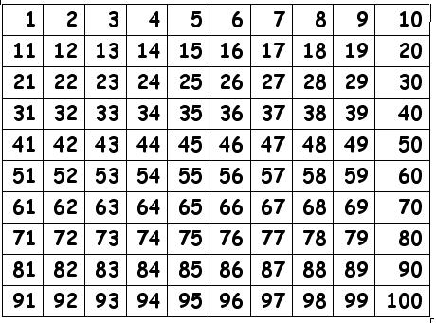
The aim of the game is to get to 100
before your opponent.

What you need:
- Two or more players. Coloured counters.
- A 100 square
- Dice: choose from
(easy) 1 die
(medium) 2 dice [1-6] add scores
(harder) 2 dice [1-9] add scores

Rules for ‘The 100 Square Race’ GAME

- Choose a coloured counter for each player.
- Roll a die, the highest scorer goes first.
- Roll the die/dice and add the scores if you have two dice.
- Move your counter along the 100 square by this amount.
- The next player takes their turn.
- Only one counter can be on a number square.
- Your counter can jump on a square with a counter to get past it.
- If your counter lands on another players counter, your counter takes that square and your opponent’s counter goes back to the start! Use number bonds to help you add on…

