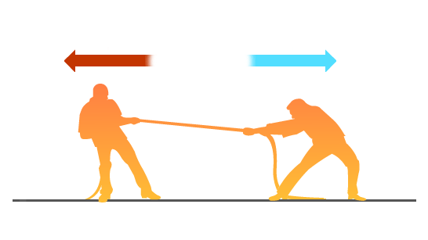
Subtract Add

The Tug of War Game
Minus Plus
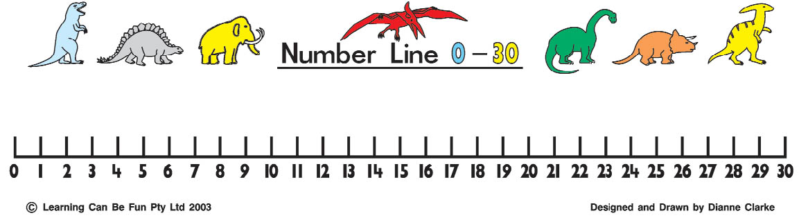

The aim of the game is to get the counter to the number 1 if you are subtracting or number 27 if you are adding from the starting point at number 14.
What you need:
- Decide who will be Minus and Plus.
Minus will move the counter to the left. Plus will move it to the right.
- Take it in turns to throw the two dice and add the scores.
- Move that number of places in your direction.
- If the counter reaches 1, Minus has won. If the counter reaches 27, Plus has won.
- Two players.
- A number line
- Two dice
- One counter

