Flow

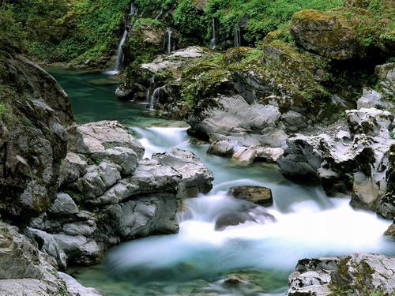 | Where do rivers come from?  How do we look after them?  What lives in them?  What happens if they flood?

Topic Homework

For this half term you are to choose and complete one of the tasks below to hand in to your teacher.
Write a story about a river creature…maybe a trout, frog, water vole, kingfisher….the choice is yours.  What adventures do they have? Who are their friends?  What is their home like? | Write and illustrate a poem  about a river.  What journey does it go on as it travels from the mountains to the sea?
Create a campaign to keep our rivers clean and free of pollution.  Present your campaign as a poster, PowerPoint or leaflet… | Design and build a bridge that could cross a river.  You can use any materials you like  ( straws/ lolly sticks etc).
Make a model of a river of your choice from its start point to the sea. Show the landscapes it goes through and who and what lives by its side. | FLOODS! Write a fact file about a real life river flood. What caused it to happen and what were the consequences?

