Make Ten
The aim of the game is to win two cards that total 10.

What you need:
- Two players.
- A pack of cards
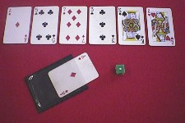

Rules for ‘Make Ten’ GAME

- Picture cards count as zero 0 and an Ace is equal to 1
- Shuffle the cards and place 6 cards face up in a line.
- Deal the rest of the pack between the two players face down.
- Player 1 turns a card over:
If the card can be paired with its number bond to 10, the player wins both cards and puts it in their winning pile. They have another go until they cannot make 10 with their card and the line of cards. They need to add their unpaired card to the line.
- Player 2 can have a go now:
They will pair the cards from their pile with the cards on the table to make 10 until they have to leave a card down.
- The winner is the one who has no more cards to play with.

