What to do today
IMPORTANT Parent or Carer – Read this page with your child and check that you are happy with what they have to do and any weblinks or use of internet.

- Read Hamilton Group Reader Purple is Best
- This is a non-fiction (information) text and tells us about how people have used dyes to colour their clothes for many centuries.

- Prepositions
- Watch the PowerPoint presentation on prepositions OR read the learning reminders about prepositions (keep these to help you with tomorrow’s work).
- On the ‘Purple is Best’ extracts sheet underline the prepositions. (Tip: use the list of prepositions on the first learning reminder card to help you).
- Write five sentences of your own about Purple is Best using prepositions. Can you use each type (time, place, cause) at least once?

Now work with a grown-up to check the answers.
Discuss any answers which you didn’t quite get. Can you see what went wrong?

Try the Fun-Time Extras
- Explore prepositions on BBC Bitesize https://www.bbc.co.uk/bitesize/topics/zwwp8mn/articles/zw38srd
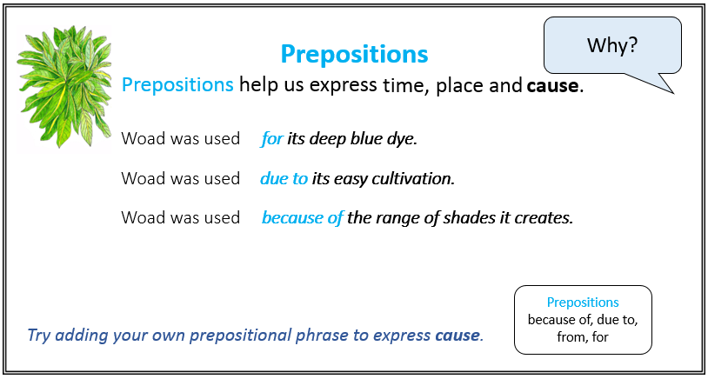
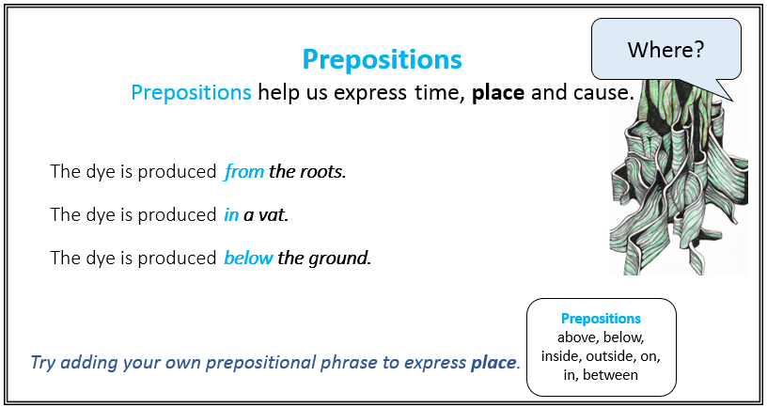
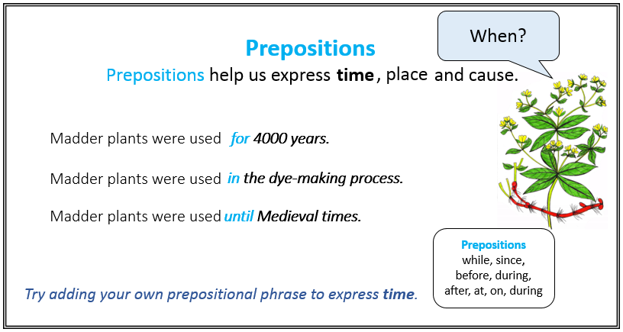
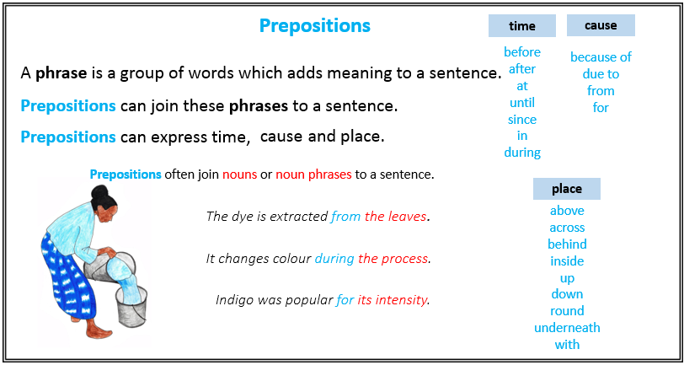

Purple is Best: extracts
Underline the prepositions in these sentences.
(Tip: use the list of prepositions on the learning reminder cards to help you)

- A group of plants called Indigofera were used across Asia.

- The blue dye has to be extracted from the plant leaves.

- The leaves must be picked in the first year.

- Due to their similar results, it is not always easy to say whether indigo or woad were used.

- You need to reduce the wood and soak it, for the right colour.

- Imperial Purple was an immensely valuable dye in the ancient world.

- Imperial Purple was obtained from a small shellfish.

- The colour gets deeper and more colourful after a long time.

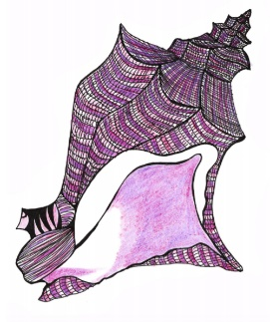

Now write five sentences of your own about Purple is Best using prepositions, can you use each type (time, place, cause) at least once?

Purple is Best: extracts (answers)

- A group of plants called Indigofera were used across Asia. (place)

- The blue dye has to be extracted from the plant leaves. (place)

- The leaves must be picked in the first year. (time)

- Due to their similar results, it is not always easy to say whether indigo or woad were used. (cause)

- You need to reduce the wood and soak it, for the right colour. (cause)

- Imperial Purple was an immensely valuable dye in the ancient world. (place)

- Imperial Purple was obtained from a small shellfish. (place)

- The colour gets deeper and more colourful after a long time. (time)

