Hi everyone
I hope you’re all okay.
I was thinking we can do a Zoom Call on Monday at 11.30am. The children can bring something to show but if we could keep it one thing and to about a minute as I’d really like to read them a story this week. I have a new one that I know they’ll love. If some children don’t want to take part, they are more than welcome to just come on and listen.
I’ve put the work into three separate emails again for ease.
Please do email if you have any questions.
Mrs Burnett
English
Continuing with Hamilton
As I have previously said, please don’t feel you have to get through all the work as it is a lot to get through in a week. You may like to pick and choose some of the activities. I have also added a topic session which links to recipes and instructions that you may choose to do one day instead of the Hamilton.

Maths
White Rose
Sheets and answers attached.

Topic
Senses
- Make your own scented playdough using herbs and spices and write the instructions how to make it. Page border attached and also recipe.
- There is a grid attached the use the senses to describe herbs and spices thinking about look, taste, smell and feel.
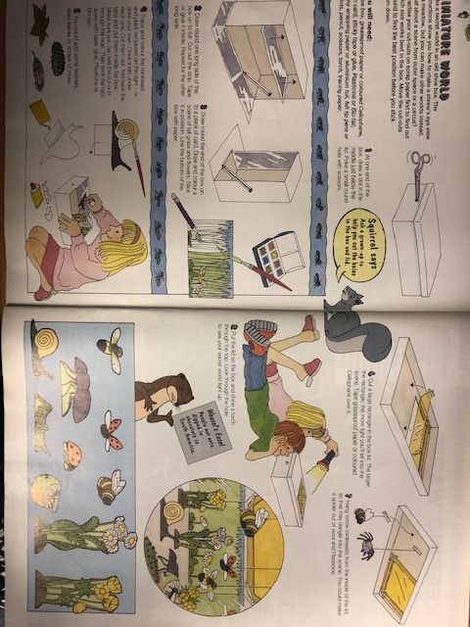
Create a miniature world in a box

Make a nature mask
