Summer 2nd half term Learning Journey Year R | Why is Water Wet?
Rationale: During this learning journey the children will:  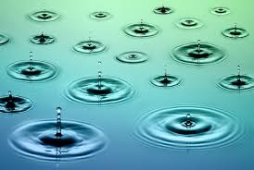 | - Find out where water comes from  - Why we need water to survive  - Find out how we use water to keep ourselves clean and healthy  - Learn how to keep safe near water  - Find out about creatures who live in and around water  - Explore ways that people use water to have fun and keep fit  - Discover the ways that water can move and change shape
HIGH QUALITY OUTCOMES IN LEARNING JOURNALS  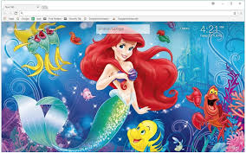 | - Read a range of stories and poems about watery worlds  - Discover underwater creatures  - Write watery poems  - Create a fantasy sea creature  - Are mermaids real? - The Lost City of Atlantis  - Roleplay – A Fishing Boat  - Explore water in different states-steam,ice,rain,snow  - Science investigation; investigate floating & sinking. Do some materials float better than others? Does it matter what shape a boat is?  - Design/create a fountain
LITERACY LINKS
Planet Earth. Under the Sea. Imagine. Magic Beach. The Raindow Fish. Wynken, Blynken and Nod. Sharing a Shell. Once upon a Tide. One is a Snail, Ten is a Crab. The Snail and the Whale, The Storm Whale, The Man whose Mother was a Pirate, Dougal’s Deep Sea Diary and a few more that I can fit in!
This will also extend into Pirates, Smugglers, Treasure Islands and how to look after our Oceans
Please keep sending your stories and your work in to lburns@march.w-sussex.sch.uk and I will be able to print them and stick your work into your Learning Journals.

