Poem about Chichester
C____________________
H____________________
I_____________________
C____________________
H____________________
E____________________
S____________________
T____________________
E____________________
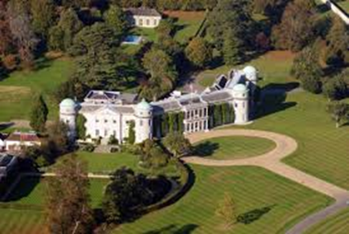
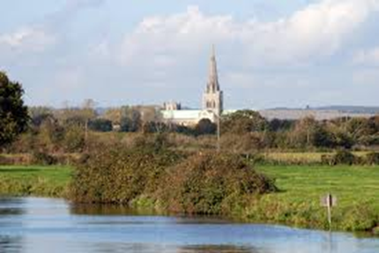
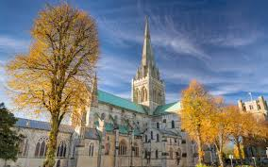
R____________________

