What to do today
IMPORTANT Parent or Carer – Read this page with your child and check that you are happy with what they have to do and any weblinks or use of internet.

1. Listen to a story
- Listen to the reading of King of the Sky https://www.youtube.com/watch?v=Mz5SBh4A9mg&t=2s
- Which part of the story did you like best? Does it remind you of any other stories that you have seen or read?

2. Answer some questions
- Read King of the Sky – Text and Questions 1. Answer the questions.
- Go on… Challenge yourself to read and answer the questions on King of the Sky – Text and Questions 2.

3. Write descriptions of places
- Look at the pictures of St Peter’s Square in Rome and Tredegar in Wales.
- Write some Descriptive Words and Phrases about each of these places. What do you notice? How could you describe it to someone who couldn’t see the photographs?
- Write a description of the view from your home. Try to make it really clear so someone can imagine it without actually seeing it. Notice small details, like the brickwork, or the shape of windows.

Try the Fun-Time Extra
- Watch this trailer for a play based on King of the Sky.
https://www.youtube.com/watch?v=UlX5Tv9ixIo
- Can you make up a play-scene from the story? You could write a script or you could act it out with toys or with people in your house.
King of the Sky – Text and Questions 1

It rained and rained and rained.
Little houses huddled on humpback hills.
Chimneys smoked and metal towers clanked.
The streets smelled of mutton soup and coal dust
and no one spoke my language.

- Why do you think the writer has repeated the word ‘rained’?

- What alliteration* do you notice in the second line?
- What sound do the metal towers make?
- What smells are there on the street?
- How do you think the boy feels if no-one speaks his language?
*Alliteration: words beginning with the same sounds

All of it told me this is not where you belong.

- Can you think of a time when you felt like you did not belong? How did that make you feel?

King of the Sky – Text and Questions 2

Just one thing reminded me of home – of sunlight, fountains and the vanilla smell of ice cream in my granny’s shop.
It was Mr Evan’s pigeons in their loft behind my house,
cooing as if they strutted in St Peter’s Square in Rome.

- When the boy thinks of home, what three things does he think about?
- What one thing reminds him of home?
- Who do the pigeons belong to?
- What noise do the pigeons make?
- What does the word ‘strutted’ mean?

St Peter’s Square in Rome

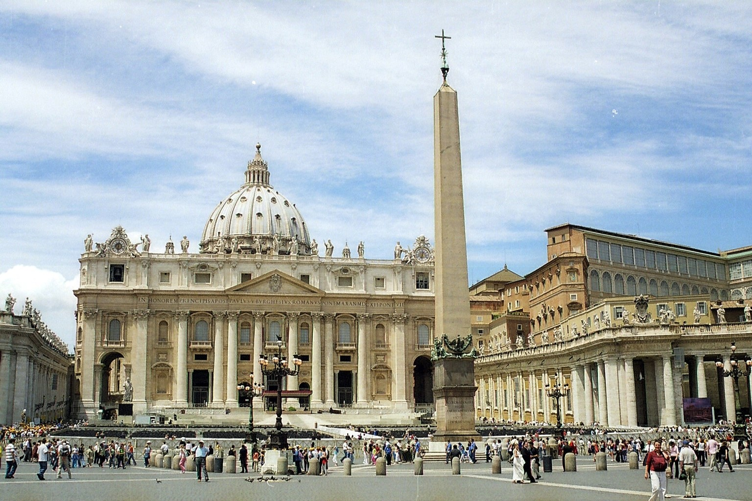

Tredegar in Wales

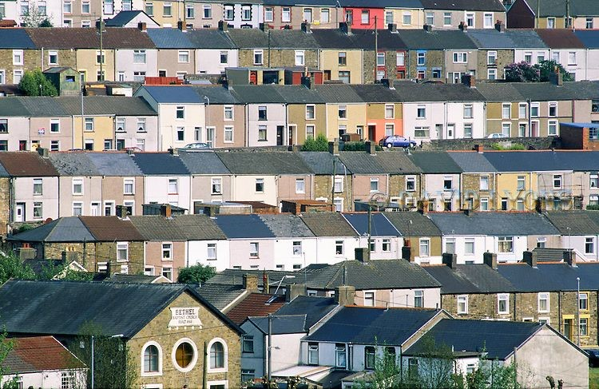

Descriptive Words and Phrases

St Peter’s Square | Tredegar

My View

Write a description about the view from a window in your home.

