WALT: understand how we have an impact on our local environment

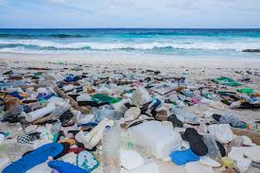
How does this picture make you feel?

What has happened?
__________________________________________________________________________________
__________________________________________________________________________________

How can we stop this from happening?
__________________________________________________________________________________
__________________________________________________________________________________

Name three things which are made of plastic.
___________________________________
___________________________________
___________________________________

Why can plastic be really useful?
__________________________________________________________________________________
__________________________________________________________________________________
__________________________________________________________________________________
_________________________________________________________________________________

