Gods and Mortals
Topic Homework
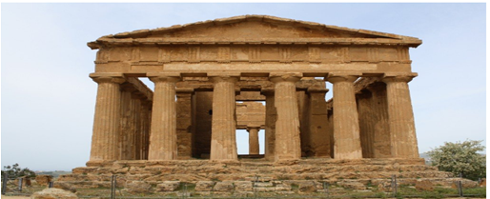

Who were the Greek Gods?
Why is much of our culture still influenced by this ancient civilization?

Build your own Greek Temple.  Which God is it dedicated to?  A Greek God or one of your own?  What will be the God’s symbol?  What powers would the God have that could be shown in the design of the temple? | Design your own mythical creature. Which animal body parts will you include? What personality will it have?  Give it name.  You can use any materials you choose to design and/or create it.
Prepare to be an athlete who can compete in the Olympic Games.  Which sport (s) are you training for? What is your daily training routine? | Make a set of Greek Gods/ Goddesses top trump cards.  List their powers/ what are they the God of? What weapons do they have?
Create a portfolio of pictures and information on buildings influenced by Greek Architecture.  Where are they?  What Greek features do they have?  BIG CLUE…there is one on East Street in Chichester. | Read a Greek Myth e.g.  The Story of Medusa or The Story of Narcissus.  Either re-tell the story using your own words and pictures or write your very own Greek Myth.
Free Choice  You may also think of your own homework idea connected to our topic. | Free Choice  You may also think of your own homework idea connected to our topic.

