What to do today
IMPORTANT Parent or Carer – Read this page with your child and check that you are happy with what they have to do and any weblinks or use of internet.

The activities today need you to work with a grown-up or someone your age (or a bit older). If there’s no-one around today to do that, then you might be best to miss this day out for now and do another one instead.

1. Make some strange creatures
- Look at Strange Creatures. What names would you give these creatures? How would you describe them to somebody else? Can you work out how they have been made?
- Follow the instructions on Make your own Strange Creatures and make your own.

2. Make some strange sentences
- Read Strange Sentences. What do you imagine in your head when you read them? Can you work out how they have been made?
- Follow the instructions on Make your own Strange Sentence to make your own.

3. Make a strange story
- Read the Strange Story. Can you work out how it has been made?
- Follow the instructions on Make your own Strange Story to make your own.

Strange creatures

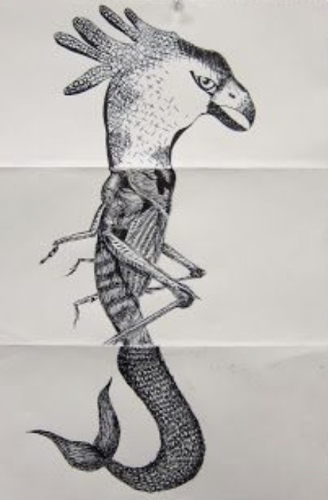 | 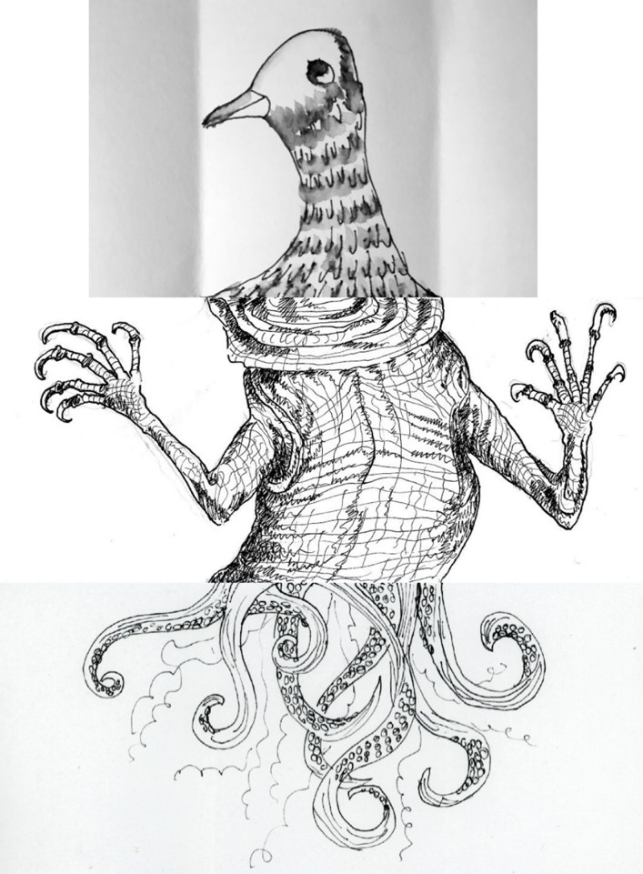
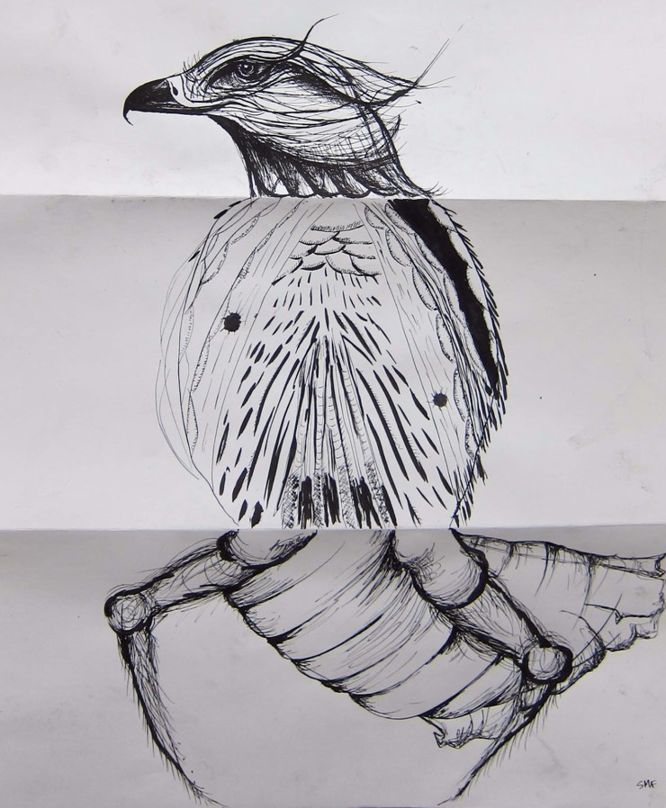 | 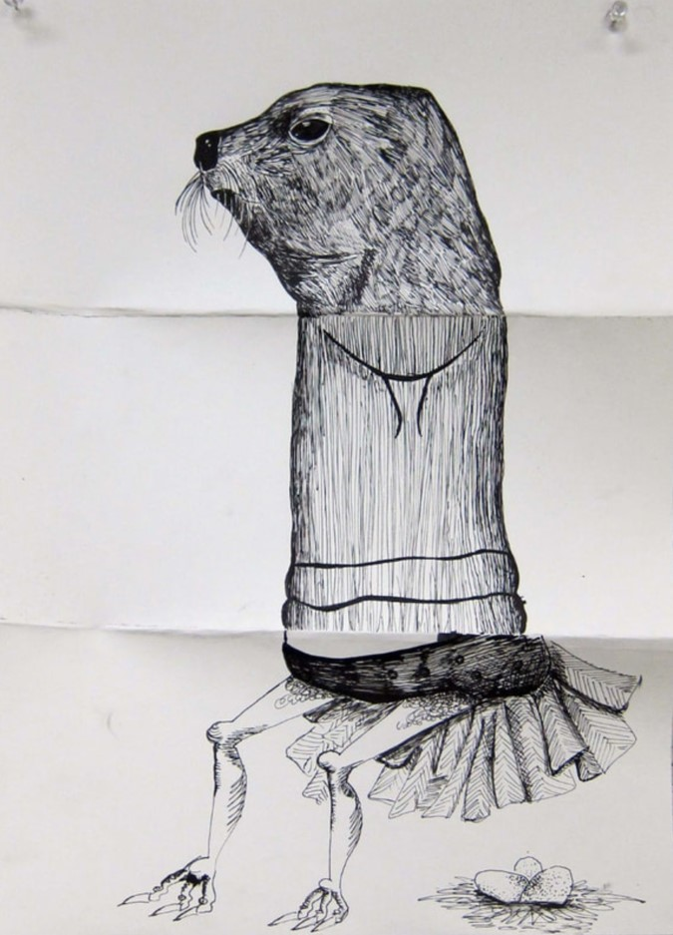

Make your own Strange Creatures

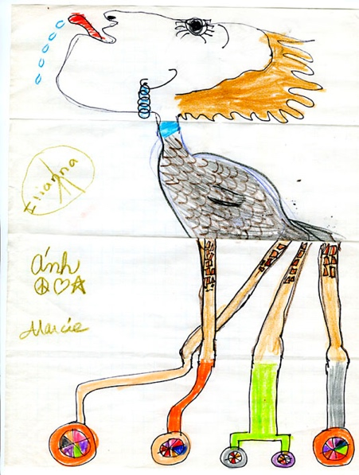

You will need:
At least one other person to work with.
Plain A4 Paper

- Each fold a plain piece of paper into equal thirds.
- Add the words Head/Body/Legs on the three sections.
Use small writing to do this.
- Draw the head on your own paper. Extend the lines just over the fold. This will help the next person.
- Fold the paper so that they can’t see the head you have drawn.
- Pass them your paper.
- Draw the body. Slightly extend the lines over the fold again.
- Swap papers.
- Draw the legs.
- Unfold the paper to admire your creation.

Strange Sentences

The orange familiar penguin stumbled towards some unlucky quaint eels.
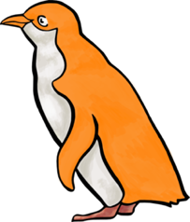

Silent picturesque trees explored late precious violins.
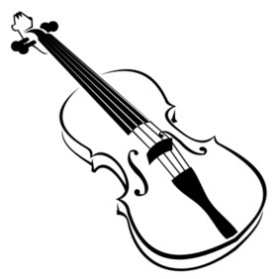

The confused, heart-warming banana stirred the solitary delightful fork.
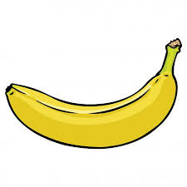

Make your own Strange Sentence
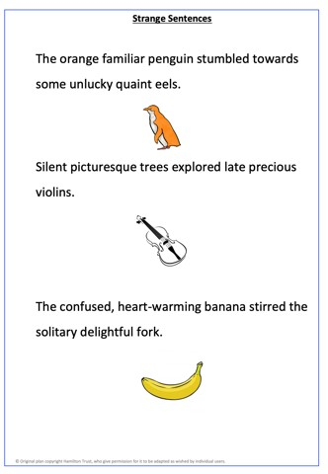
You will need
At least one other person to work with
Strange Sentence Maker

- Write five different adjectives in the first column without the other person seeing.

- Fold the paper so that this column cannot be seen

- Give the paper to the other person.

- They write five adjectives in the second column without you seeing.

- They fold the paper so the column is also hidden.

- Take the paper and write five nouns. Fold the paper and hand back to them.

- Keep repeating until the last column is complete.

- Unfold the paper and read the sentences that you have created. You may have to add some extra words to make them make ‘sense’.

Strange Sentence Maker - Examples
Adjective | Adjective | Noun | Verb | Adjective | Adjective | Noun
orange  angry  serious  confused  silent | familiar  succulent  icy  heart-warming  picturesque | penguin  pencil  bottle  banana  trees | stumbled  trekked  jostled  stirred  explored | unlucky  extreme  annoyed  solitary  late | quaint  courageous  striking  delightful  precious | eels  phone  tissue  fork  violins

Strange Sentence Maker
Adjective | Adjective | Noun | Verb | Adjective | Adjective | Noun

Strange Story

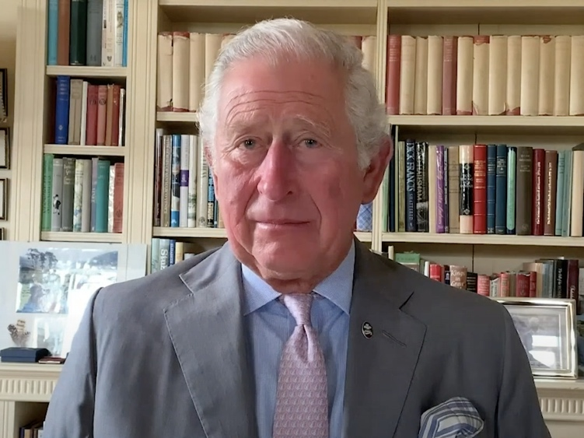

JK Rowling met Prince Charles at the edge of the forest. She said, “I wanted to buy some fish.” He said, “Umbrellas are only useful in light rain.” She did some break-dancing. He flapped his wings and tried to escape. The consequence was that they managed to unlock the door.

Make your own Strange Story
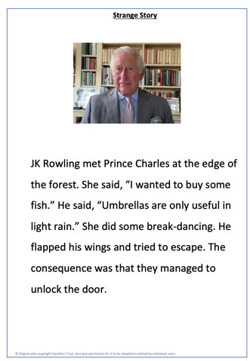
You will need
At least one other person to work with
Strange Story Maker

- Each person starts with a copy of Strange Story Maker. Each person writes the name of a famous woman as the first step in a story, and then fold the paper to hide the name before passing it to the next person.
- Everyone then writes the name of a famous man, folds and passes on their paper.
- Carry on until all the sections are filled.
- Unfold your paper and read your stories.

Strange Story Maker

Name of a famous woman
Name of a famous man
met
The place that they meet
in/at/on
She said:
He said:
What she does
She
What he does
He
What happened
The consequence was

