What to do today
IMPORTANT Parent or Carer – Read this page with your child and check that you are happy with what they have to do and any weblinks or use of internet.

1. Find out about six types of dragons
- Look at Dragon Pictures. What can you spot in each picture that someone else might not notice?
- Read Dragon Descriptions. Look for any clues that will help you to match each description to the right picture.
- Then check your thinking with the Answers which are upside down at the bottom of the page.

2. Make a dragon quiz
- Read Dragon Questions. How many can you answer?
- Check your answers with Dragon Answers.
- Write a Multiple-Choice Quiz. Write three options for each question: the right answer, a close answer and a ridiculous answer. Don’t always put these in the same order.
- Try your quiz out on some other people. How many can they get right?

3. Invent your own dragon
- Draw your own dragon. Write a description of it. You can make up your information!
- Look at the Top Trumps Example. Make a Top Trump card for your dragon. You could make Top Trump cards for the six other dragons too.

Dragon Pictures
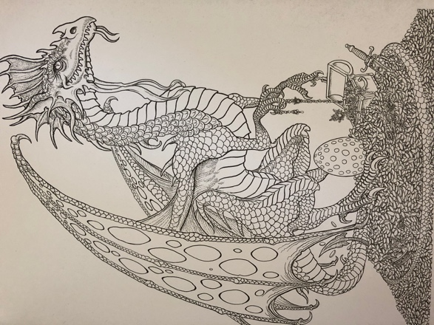  A | 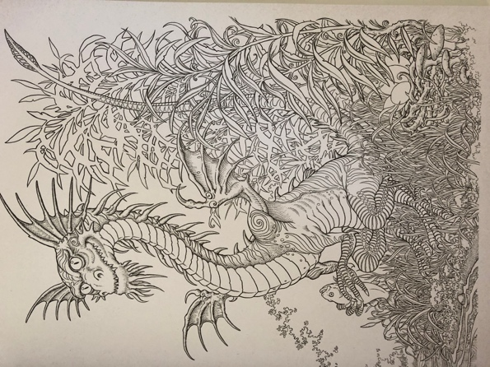  B
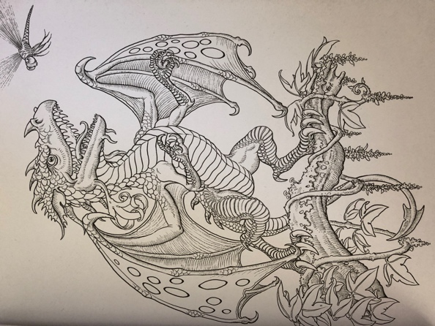  C | 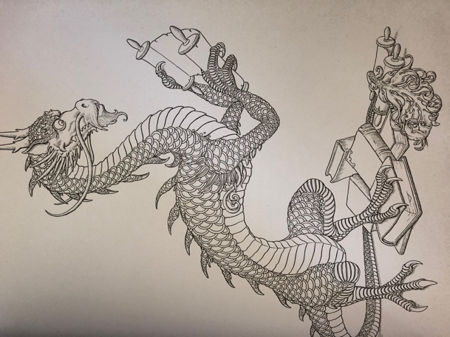  D
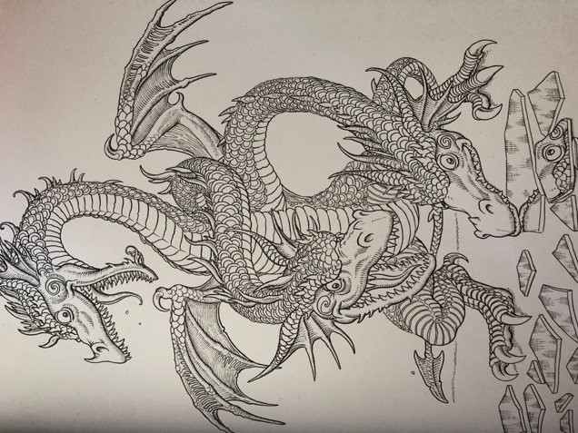  E | 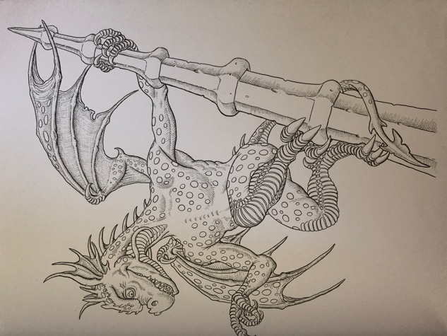  F
From Dragonology The Colouring Companion by Dugald A Steer
Dragon Descriptions

Match the description to the picture. Look carefully at the picture for clues and read the writing looking for any links.

Dwarf Dragon
Dwarf dragons are small and naturally mischievous. They can be tamed but will bite their owners. They eat dragonflies and other smaller insects. They live in colonies. They have a large head with a prominent nose horn.

Gargouille
Masters of camouflage, gargouilles can be found perching amidst the stonework of city buildings. This species has spread throughout cities in Europe – feeding on rats, bats, cats and occasionally human food. Their small wings prevent them from being accomplished fliers, so they rely on surprise attacks from above. They sit without moving for days. Their body is covered in leathery skin, which can withstand any amount of heat.

Knucker
The knucker chooses to live in a damp location. It enjoys eating fish, rabbits and farm animals. Larger species have been known to take deer and even stray children. A knucker’s call is a low gurgling noise that sounds like water draining away. Knucker’s have small heads and a long body. They are flightless.

European Dragon
European dragons have learnt many languages and can now be found in mountainous regions throughout the world. This dragon loves to collect treasure. Gold is the metal that it seeks most. They have an intelligent appearance. Their bellies are smoother and paler than the rest of their bodies and have less armour than their back and sides.

Japanese Ryu
Japanese Ryu love water and are found all over the islands of Japan. Their lairs are situated underwater. They eat a wide range of foods, from wild boar to carp but they are particularly fond of cherries. They can communicate in writing, using their tails as brushes. They have antler-like horns and prominent whiskers.

Hydra
A hydra’s preferred food is other dragons’ chicks. Individuals have three to seven heads which are known to fight among themselves. They reproduce by splitting – one head separates from the body to form a new creature. They are able to learn many languages and have been friends to humans.
Adapted from: Dragonology The Colouring Companion by Dugald A Steer

Answers

Dwarf Dragon C Gargouille F
Knucker D European Dragon A
Japanese Ryu B Hydra E

Dragon Questions

What do dwarf dragons eat?

Why do gargouilles launch surprise attacks?

What is special about a gargouilles’ skin?

Name one type of dragon that cannot fly?

Which metal do European dragons most like?

Where do European dragons live?

Which fruit do Japanese ryu enjoy?

What do Japanese ryu use for writing?

How many heads does a hydra have?

What do hydra prefer to eat?
Dragon Answers

What do dwarf dragons eat? (Dragonflies)

Why do gargouilles launch surprise attacks? (They are not strong fliers)

What is special about a gargouilles’ skin? (It can withstand any heat)

Name one type of dragon that cannot fly? (Knucker)

Which metal do European dragons most like? (Gold)

Where do European dragons live? (Mountainous regions)

Which fruit do Japanese ryu enjoy? (Cherries)

What do Japanese ryu use for writing? (Their tails)

How many heads does a hydra have? (3-7)

What do hydra prefer to eat? (Dragon chicks)

Multiple Choice Quiz
Make up multiple choice options for each question.
Make one ridiculous and one close to the real answer.
Two have been done for you. Put the right answer in different places, sometimes as A., sometimes as B. and sometimes as C.
What do dwarf dragons eat?  - Dragonflies  - Fireflies  - Hamburgers | Why do gargouilles launch surprise attacks?  - They love surprises  - They aren’t strong  - They aren’t good fliers

What is special about a gargouilles’ skin?

Name one type of dragon that cannot fly?

Which metal do European dragons most like?

Where do European dragons live?

Which fruit do Japanese ryu enjoy?

What do Japanese ryu use for writing?

How many heads does a hydra have?

What do hydra prefer to eat?
Design Your Own Dragon
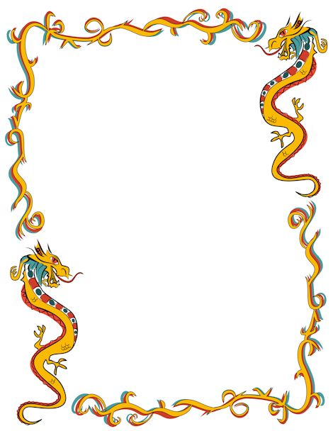

Top Trumps Example

