Year 3 Home Learning
Week of 20th April 2020

Maths
Moving forward we will be using the White Rose Home Learning resources found here: https://whiterosemaths.com/homelearning/year-3/. As we have just started using this home learning tool we are starting with Week 1.

Each day there is a short video followed by a written activity. If you are not able to print the sheets do not worry at all, you can record the answers on a piece of paper. Once you are finished you can check your answers on the resource provided.

Activity 1
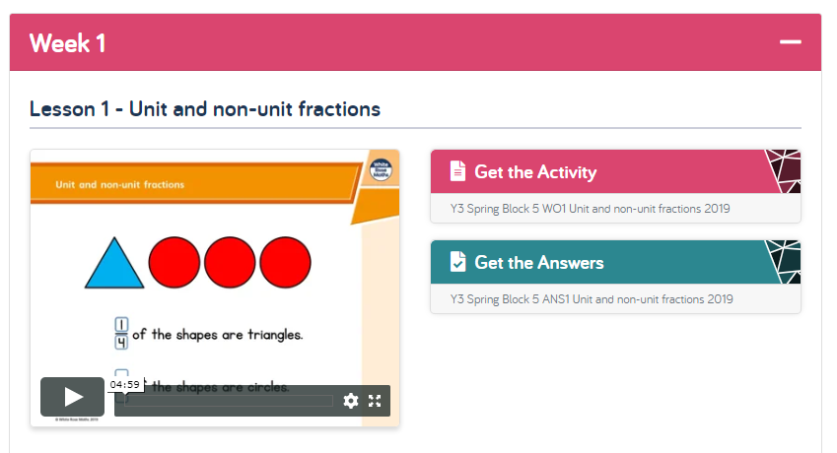
Activity 2
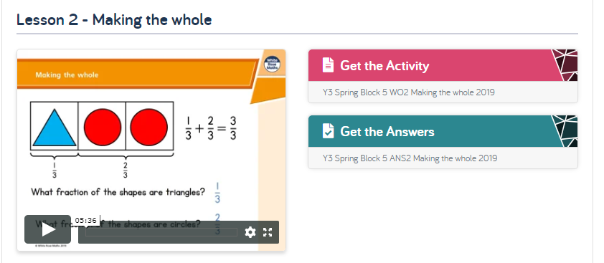

Activity 3
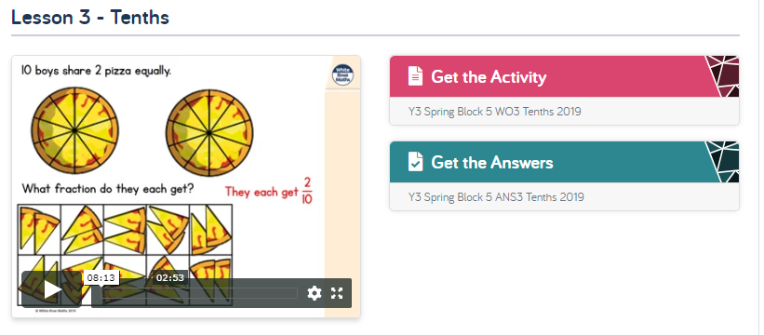
Activity 4
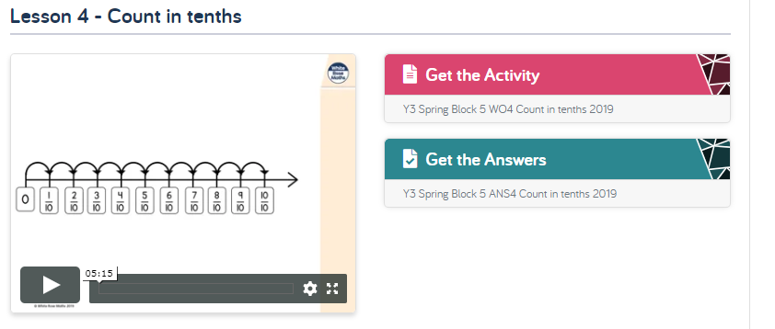
Activity 5
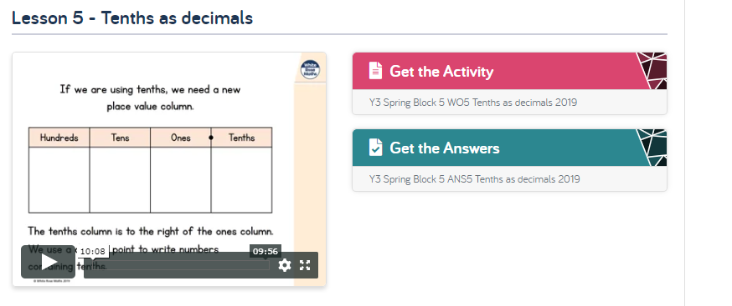

English

BBC 500 Words 2020: LKS2 Mission 500 Resource Pack
https://www.twinkl.co.uk/resource/bbc-500-words-2020-lks2-mission-500-resource-pack-t-e-2549304

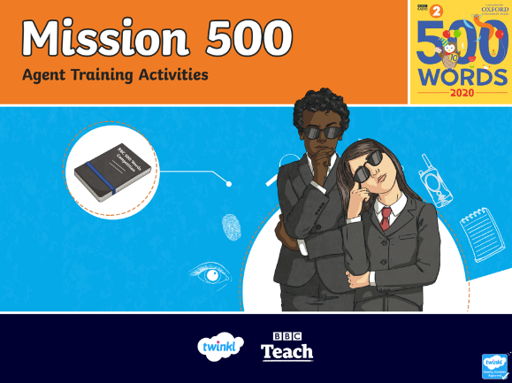
I thought it would be a lovely idea to take part in this BBC 500 Words Challenge. There is a PowerPoint presentation that will guide you through and lots of challenges to complete. Each week we can focus on one challenge and one piece of writing or if you are feeling like you would like to do more than feel free to carry on. I would love to see the work you do, if you email me a photo of your writing or email me a copy of what you do I will email you back some feedback.

This week we can work on the challenge called – What are they called? Creating characters.

Open the PowerPoint and watch the introduction on Slide 2 then click on select a challenge.

On Slide 3 select the first challenge – What are they called? Creating characters.

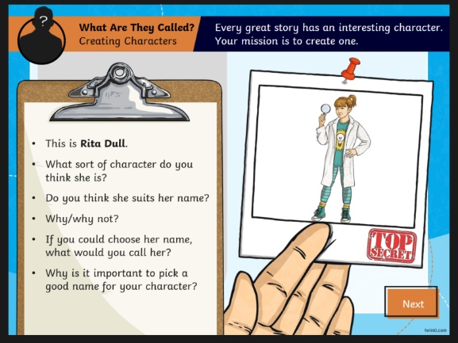
On Slide 4 there is information about Rita Dull, you can answer the questions by talking to someone else in your house about the answers or write the answers down.

On Slide 5 you can pick one, or however many characters you’d like, and follow the instructions on the post its.
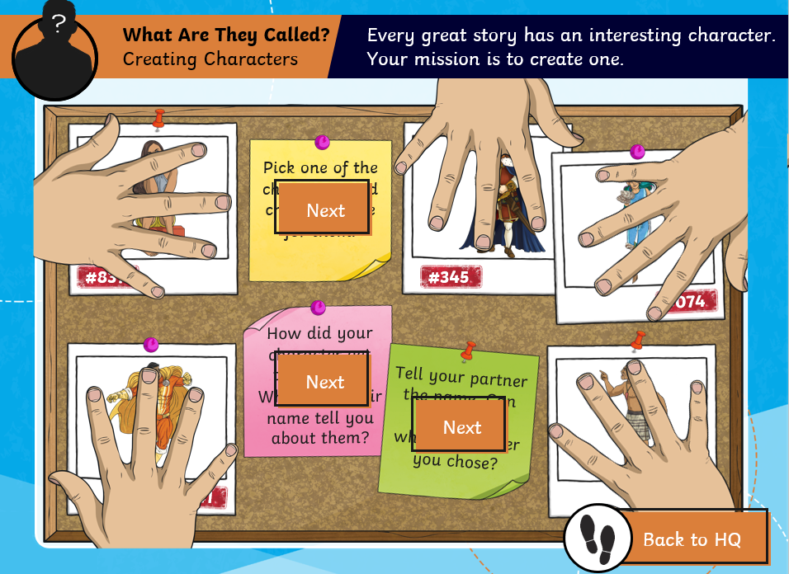

Topic Ideas

There are some fantastic science investigation ideas that can be found here:
https://www.weareteachers.com/easy-science-experiments/

This week you could learn about Georgie O’Keeffe and draw your own flower from the photo pack provided or from a real flower in your garden or one you might have seen on a walk.
