The March CE Primary KS1 Science Quiz
Week 1 – Solids, Liquids & Gases
Email your answers to: nboden@march.w-sussex.sch.uk

.
1.Mira is pouring a fizzy drink out of a can. Which one of these is a liquid?
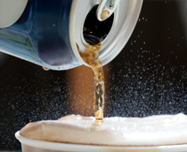
- The metal can
- The drink
- The bubbles
- The air

2.The picture shows two hot-air balloons. Which one of these is a gas?
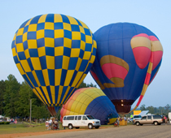
- The air inside the balloons
- The metal of the cars
- The wood of the trees
- The fabric of the balloons

3.When snow melts it turns into ____.
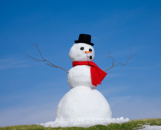
- Ice
- Water
- Air
- Cotton wool

4.When water gets very cold, it freezes. It turns into ice. Which one of these is a solid?

5.Some solids are not very hard. Butter is a soft material. Adam takes the butter out of the fridge and puts it into a warm room. What happens to the butter? The butter in the warm room is ______.
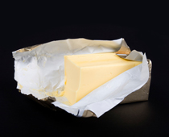
- Frozen
- Ice
- Softer
- Harder

6.Emily is watering the plants in the garden. What is Emily pouring onto the plants?
- A gas
- A liquid
- A solid
- Lemonade

7.Hannah is stirring a drink with a spoon. The spoon is a _____.
- Solid
- Liquid
- Gas
- Fluid

8.Grace's mum is blowing up a balloon. The balloon is:
- A solid inside a liquid
- A gas inside a solid
- A liquid inside a gas
- A gas inside a liquid

9.Which one of these is a solid?
- The air
- The wood of the boat
- The water
- None of these

10.When water boils it turns into steam. Which one of these is a gas?
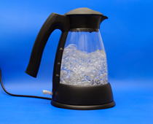
- The steam
- The water
- The plastic of the kettle
- The metal in the wires

Email your answers to:nboden@march.w-sussex.sch.uk

