Hi Class 1,

Hope you have had another lovely week doing some amazing home learning! I have seen some of your work and it is all looking amazing and I am so impressed.
Maths:
I have attached the home learning sheets from White Rose for this week.
Literacy:
I have attached the home learning sheets from Hamilton Trust for this week for the children to complete.
RE:
As the focus of RE this term is “what is a church?” I would like the children to think of a time in which they have attended church and how this has made them feel, whether this is happy or sad and why.
Science:
I have attached a science lesson for this week looking at the wind and making wind socks.
Topic:
For this week in topic I would like the children to look at shadow puppets and how they work. Using black card and a lolly stick the children can make their own shadow puppet. Making sure they understand the outline needs to be nice and neat as we cannot decorate and design shadow puppets.
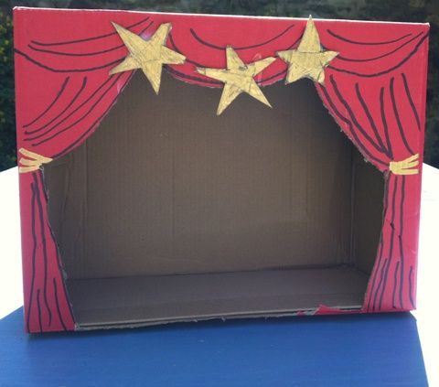
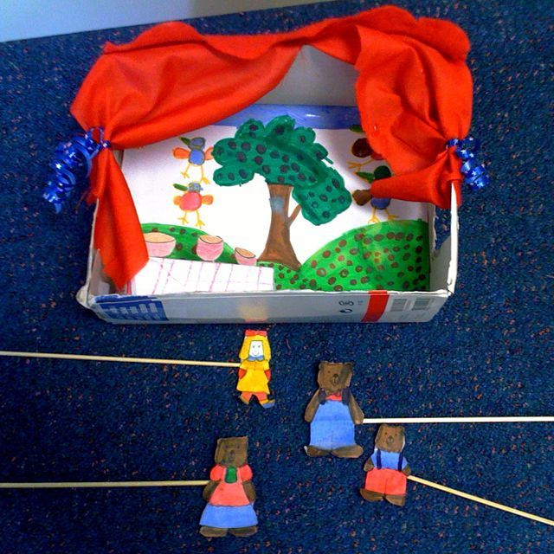
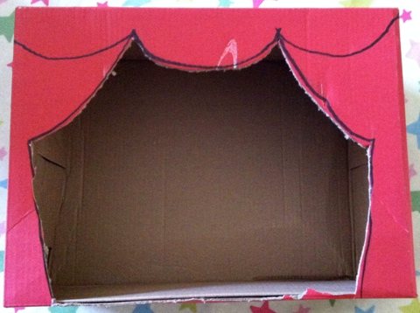
In addition to this if the children have a spare shoebox or cardboard box they can design and make their own “puppet show theatre stage” to use to perform plays with their shadow puppet. I have attached some examples below:

Hope you have another lovely week!

Miss Grounds

