Year 3 Home Learning
Week of 29th June 2020

Spellings
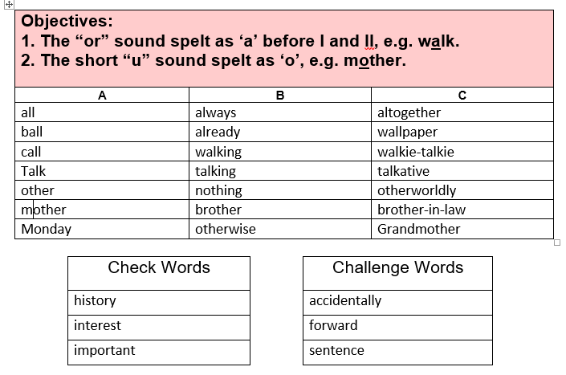

Maths
White Rose: https://whiterosemaths.com/homelearning/year-3/

White Rose Home Learning Summer Term – Week 10 (w/c 29th June)

Worksheets emailed out as attachments

Activity 1
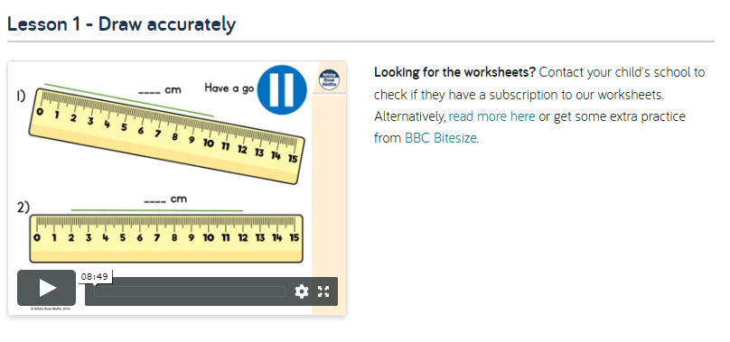
Activity 2
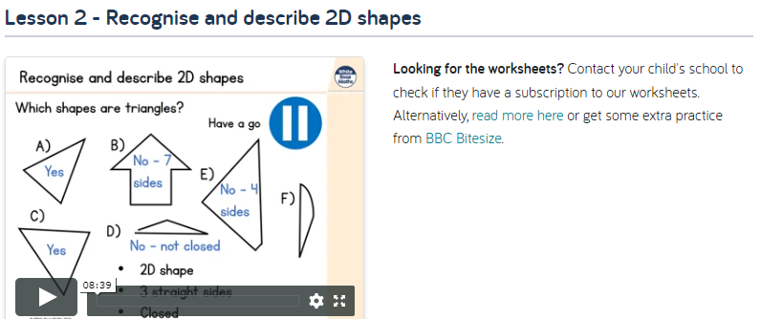
Activity 3
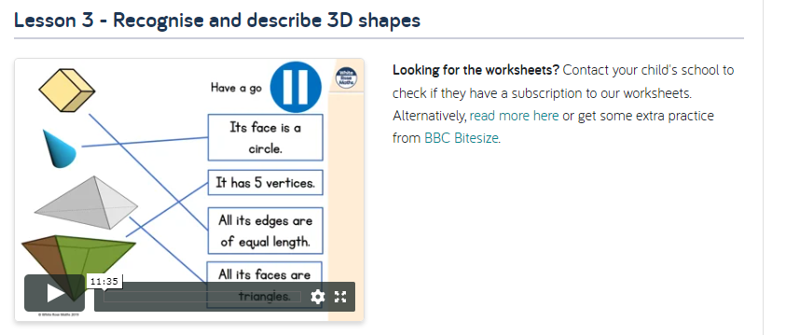

Activity 4
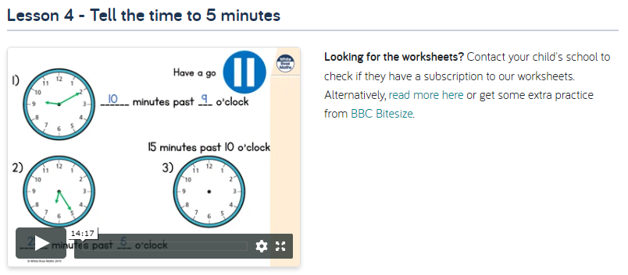
Activity 5
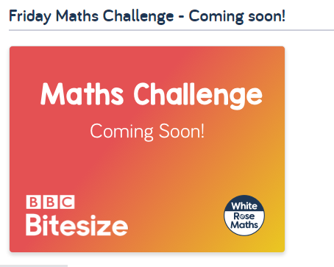

English
Hamilton Trust – Year 3 English – Week 11
https://www.hamilton-trust.org.uk/blog/learning-home-packs/
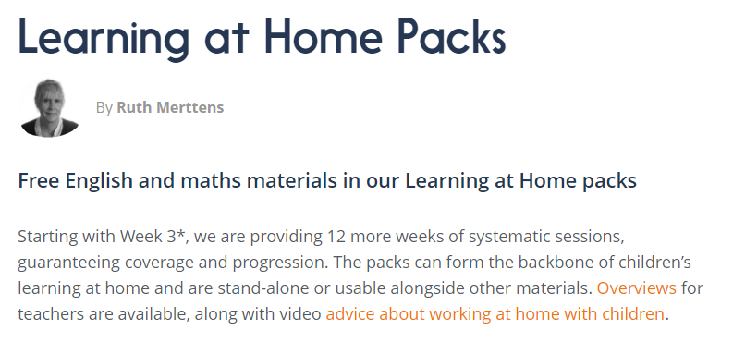
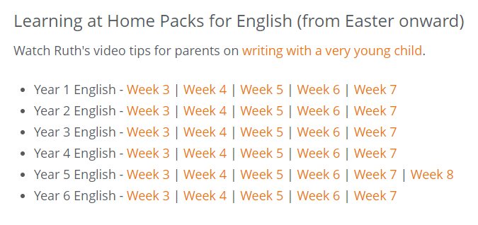

Our topic is…

Gods and Mortals
For home learning you may choose an activity from our homework grid.

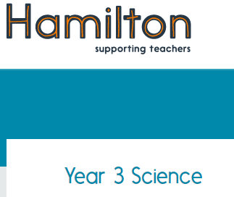
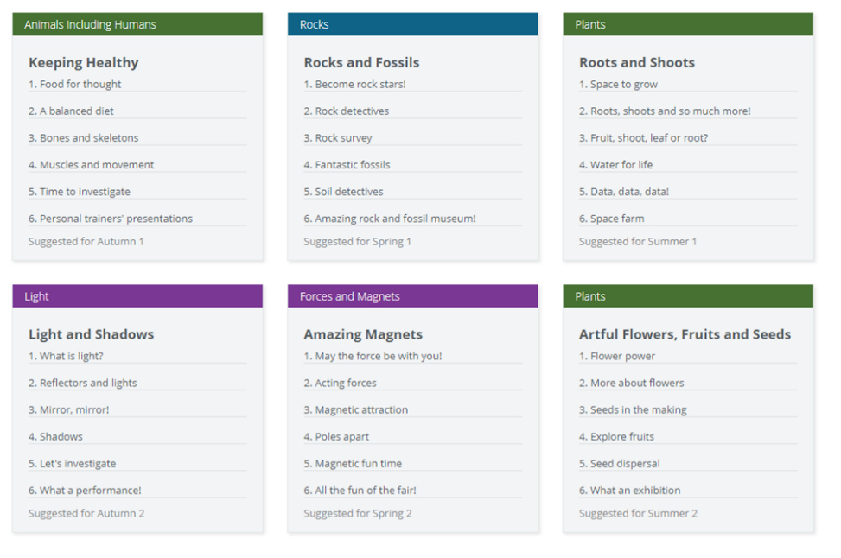

We will be having a science week in school this week. In school we will complete the unit on Forces and Magnets called “Amazing Magnets”

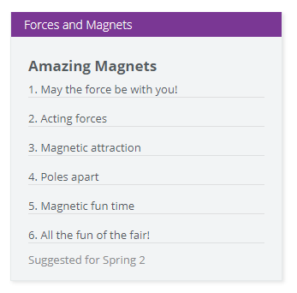

It might be tricky to source all the materials needed for this unit so you might like to complete another unit or create your own science week. Have fun!

